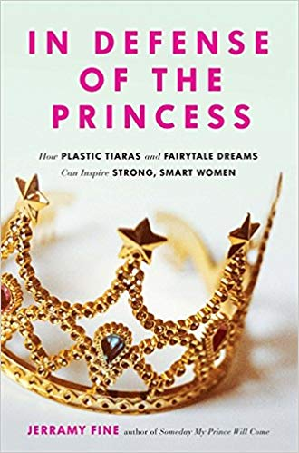

BOOK CLUB DISCUSSION QUESTIONS:
- Did you love princesses as a child? Did you daughter? How did people make you feel? How did you feel as a parent?
- Who is your favorite Disney princess and why? Who is your least favorite Disney princess and why?
- Do you think allowing girls to wear pink and play with feminine toys sets them up for failure later in life?
- When it comes to clothing and toys, why is it that boys can be boys, girls can be boys, and boys can be girls – but girls can’t be girls?
- Why are grown women so fascinated by real royal women? What is it about Diana, Princess of Wales, The Duchess of Cambridge and the Duchess of Sussex that we find so enchanting?
- Why is America, a country founded to escape the wrath of the monarchy, so fascinated by the royal families of Europe?
- What does feminism mean to you? Where has it failed? Can you be a feminist and still love all things feminine? Can you be a feminist and still believe in true love?
- Can you be a princess without a prince?
- What does “inner princess” mean to you? What can you do to stay more loyal to royal within you?
- Do you believe that women have uniquely female strengths? Why is this so controversial? How can these strengths better serve our world?
- The Dalai Lama once said that “the world will be saved the Western Woman.” How is the idea of Princess Power connected to this?

